Metal 3D Printer

# Project Proposal

Cameron Tribe, Brian Andrews,

Ahmad Qazi, Branden Driver, Dimitri Leonchik

|  |  |  |
| --- | --- | --- |
| **Revision History** |  |  |
| Cameron Tribe | 1/23/15 | V1.0 |
|  |  |  |

**The Goal:**

The end goal of this project is to fully integrate the MIG welder with the LinuxCNC system. Integration will include a way to control all of the functions of the welder, i.e. wire speed, maximum current output, engaging and disengaging the welder at appropriate times. In order for this to be done, electromechanical devices must be used to manipulate the knobs on the MIG welder. At the very least, the machine must be able to deposit material, reproducing a simple single object from a CAD drawing. This object is chosen to be a cylindrical tube, however, it is desired that the machine will be able to create complex structures on a single base. Precision of the deposition is not the primary concern, however it will be a requirement that the total amount of material deposited is more than the minimum tolerance of the part being created. This will allow for material to be machined away to a more precise tolerance.

**Our starting point**

The groundwork of this project has been completed by Aram Kasparov, the project sponsor. The project at its current state consists of a PC controlled CNC machine, a MIG welder, an infrared temperature sensor and a current measuring sensor. The PC controlling the CNC machine is running a Linux operating system. LinuxCNC an open-source software is used for programing and interfacing with the physical machine. Additional hardware is installed onto the PC, consisting of Mesa Electronics 5I20 FPGA based PCI Anything I/O card, 7i33 analog servo interface card and two 7i37-COM isolated I/O cards. The LinuxCNC software communicates the control signals and receives feedback through these cards. The CNC machine is a 3-axis machine-that is it can move in the X, Y and Z directions. Each axis is moved by a servo-motor and each servo motor is driven by a driver which receives its control commands from the PC. The machine is functional, though the motors will require some tuning and limit switches need to be programmed in (they are physically installed on the machine but not included in the program). The MIG/Flux cored welder is rated at 180 Amp-DC, 240 Volt with a duty cycle of 20% at 140 amps. The welder has current and wire feed adjustment capabilities for controlling the weld. These two knobs will be controlled by two stepper motors which have been installed onto the welder already. The current sensor has the ability to measure up to 225A. It has been demonstrated to be functional and will be used to monitor the current of the weld. The infrared non-contact temperature sensor is rated to measure temperatures up to 1800 degrees Celsius, though no tests have been performed yet.

**Requirements:**

* Must use a wire feed welder
* Welder must have a Control System
  + Must measure weld temperature
  + Must measure weld current
  + Must use both previous parameters to estimate current quality of weld
  + Must use “G code” as inputs
  + And must control when material is being deposited
* Must have user interface
* Should allow for welder thermal shutdown
* May show amount of wire left on spool

**Block Diagrams:**

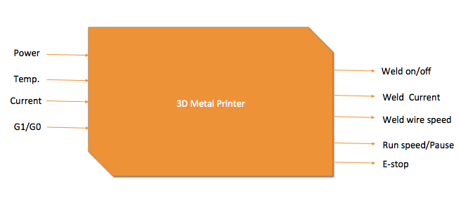

**Level 1:**

